

**Course Name: Probability and Statistics**

**Topic: Daily Study Hours of UCU Students**

**Department of Computing & Technology Semester: Advent 2025**

**OBJECTIVES**

* To design and execute a field data collection exercise on student study habits.
* To organize and summarize both grouped and ungrouped data.
* To compute descriptive statistics such as mean, median, and standard deviation.
* To visualize findings using statistical software (Excel and Python).
* To write and present a well-structured scientific report.

**METHODOLOGY**

The study was conducted using a structured questionnaire distributed to a random sample of 63 UCU students. The population consisted of available students we reached out on campus in various places such as dining hall, computer labs,halls and hostels to mention but a few. Data was collected through face-to-face interaction. We were able to reach out to students in various courses such as Law,BSIT,BSCS,BSDC and Civil Engineering among others.

Each respondent provided details such as gender, course, and daily study hours. Quantitative data (study hours) were analyzed using Excel to obtain descriptive statistics. Ethical considerations such as consent and confidentiality were observed throughout the process.

**UNGROUPED DATA FOR HOURS SPENT IN STUDIES PER DAY.**

|  |  |
| --- | --- |
| **Study Hours(Per Day)** | **Frequency** |
| 1 | 2 |
| 2 | 4 |
| 3 | 3 |
| 4 | 10 |
| 5 | 6 |
| 6 | 3 |
| 7 | 3 |
| 8 | 8 |
| 10 | 4 |
| 12 | 4 |
| 14 | 2 |
| 15 | 2 |
| 16 | 1 |
| 18 | 2 |

**GROUPED DATA**

|  |  |  |  |  |  |
| --- | --- | --- | --- | --- | --- |
| **CLASS INTERVAL (HRS.)** | **FREQUENCY** | **MIDPOINT(X)** | **CUMULATIVE FREQUENCY** | **Fx** | **Fx2** |
| 0-1.99 | 2 | 1.0 | 2 | 2 | 2 |
| 2-3.99 | 7 | 3.0 | 9 | 21 | 63 |
| 3-5.99 | 16 | 5.0 | 25 | 80 | 400 |
| 6-7.99 | 6 | 7.0 | 31 | 42 | 294 |
| 8-99 | 8 | 9.0 | 39 | 72 | 648 |
| 10-11.99 | 4 | 11.0 | 43 | 44 | 484 |
| 12-13.99 | 4 | 13.0 | 47 | 52 | 676 |
| 14-15.99 | 4 | 15.0 | 51 | 60 | 900 |
| 16-17.99 | 1 | 17.0 | 52 | 17 | 289 |
| 18-19.99 | 2 | 19.0 | 54 | 38 | 722 |
| Totals | 54 |  |  | 428 | 4478 |

**Descriptive Statistics for Grouped Data**

**Grouped Frequency Distribution**

|  |  |  |  |
| --- | --- | --- | --- |
| STATISTIC | FORMULA | VALUE | INTERPRETATION |
| Mean | Σfx / Σf | 428 / 54 = **7.93 hrs** | On average, a UCU student studies about **8 hours**  **per day** |
| Median | L + ((N/2 - CFbefore) / fm) × c | = 6 + ((27 - 25)/6)×2 = **6.67hrs** | The middle 50% of students study around **6–7 hours**  **daily** |
| Mode | L + ((fm - f1) / (2fm - f1 - f2)) × c | = 4 + ((16−7) / (32−7−6)) ×2 ≈ **4.95 hr** | The most common study duration is **about 5 hours**  **per day** |
| Range | Highest − Lowest | 19 − 1 = **18 hrs** | Indicates wide variation in study habits |
| **Variance (s²)** | (Σfx² / N) − (x̄)² | (4478 / 54) − (7.93)² = 82.92 − 62.88 = **20.04** | Shows data spread |
| **Standard Deviation (s)** | √Variance | √20.04 = **4.48 hrs** |  |

**SCALE**

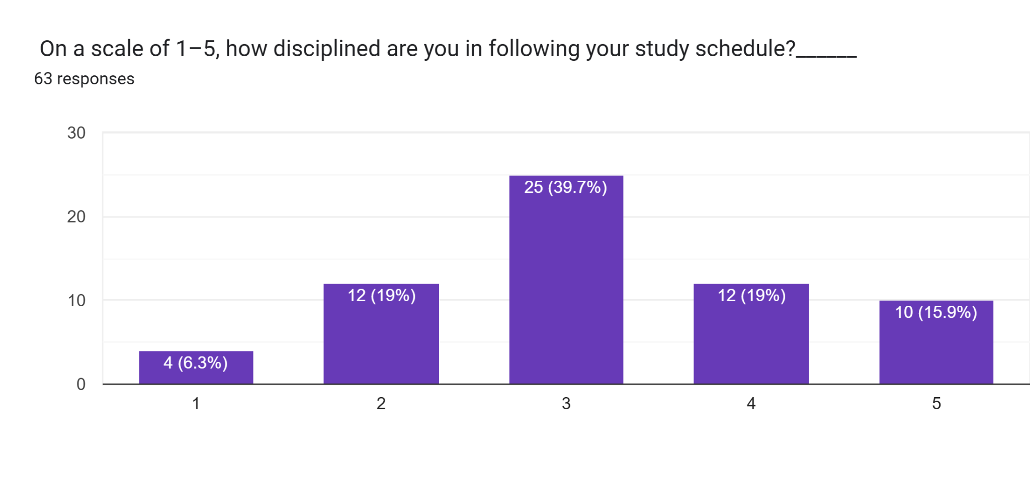

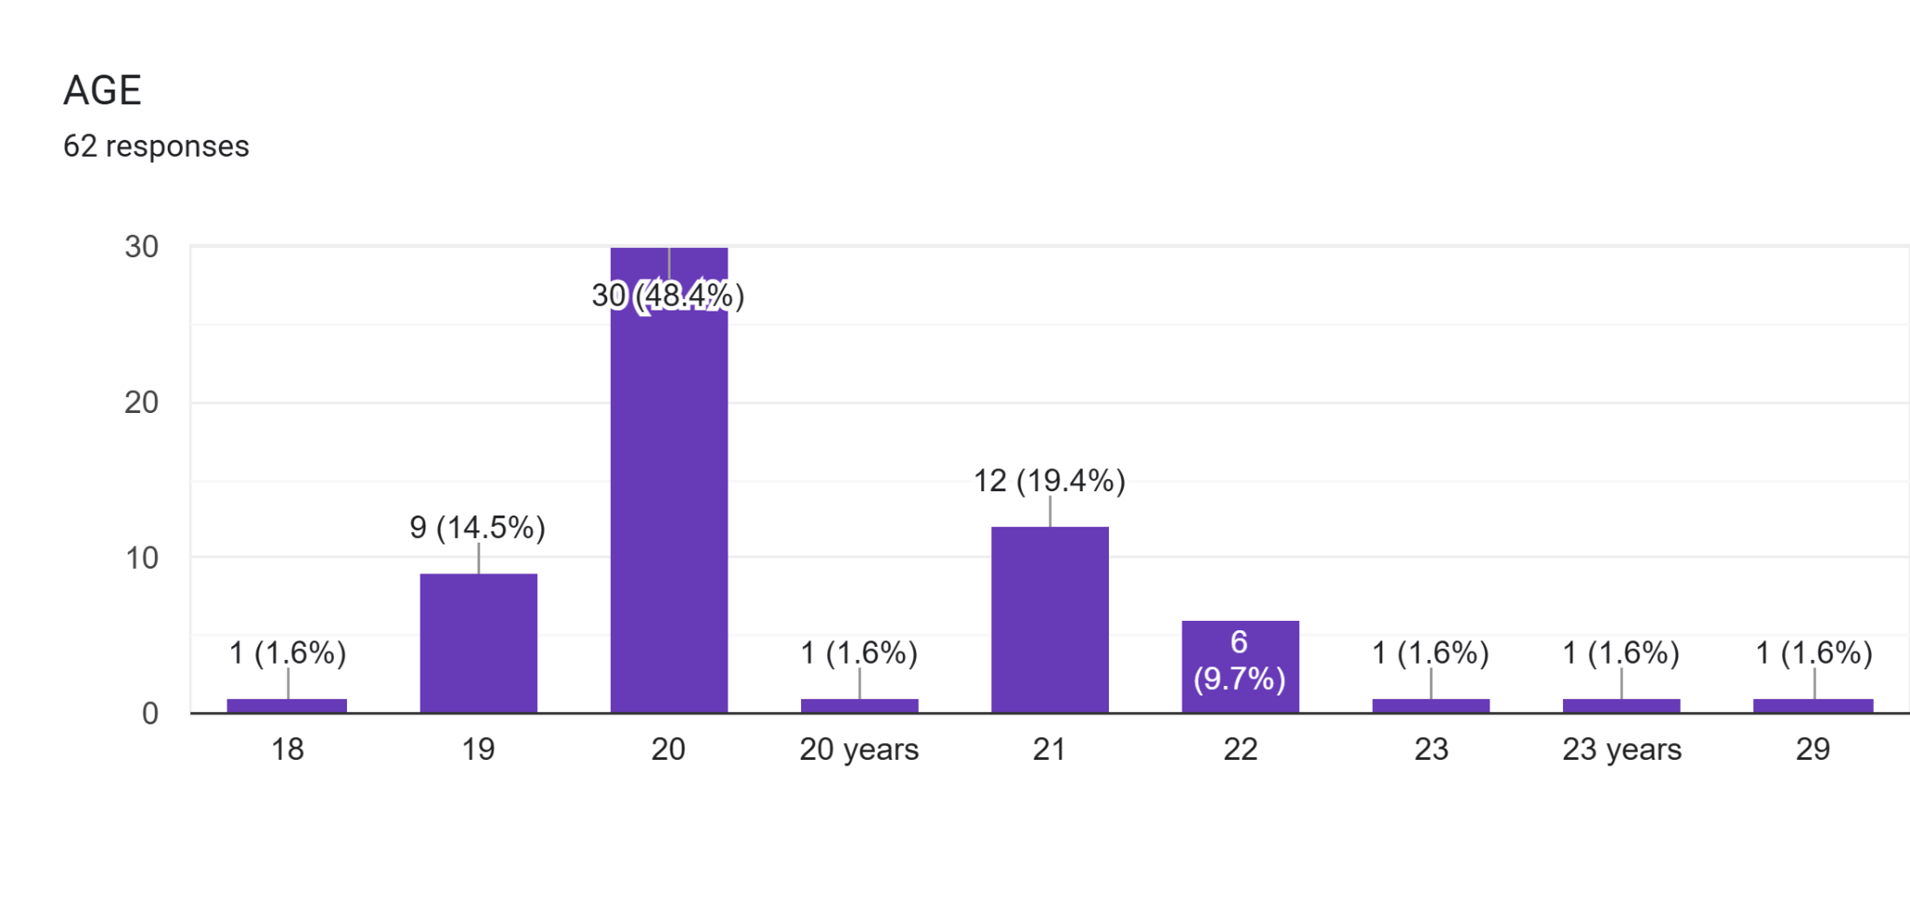

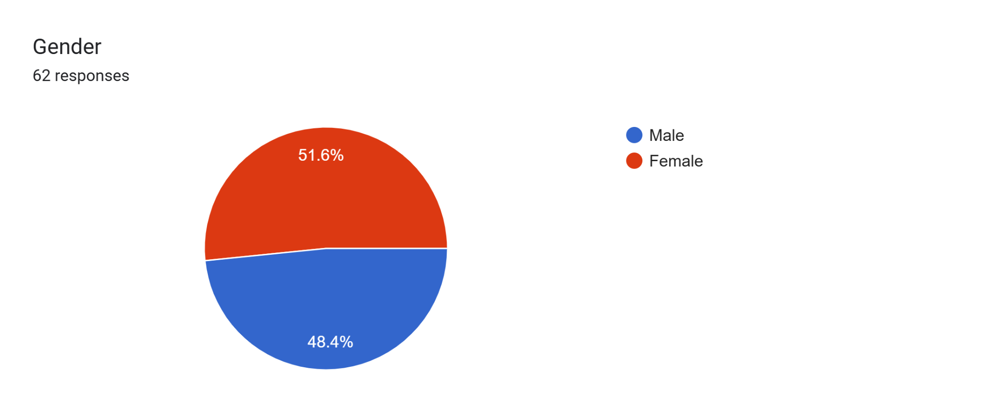

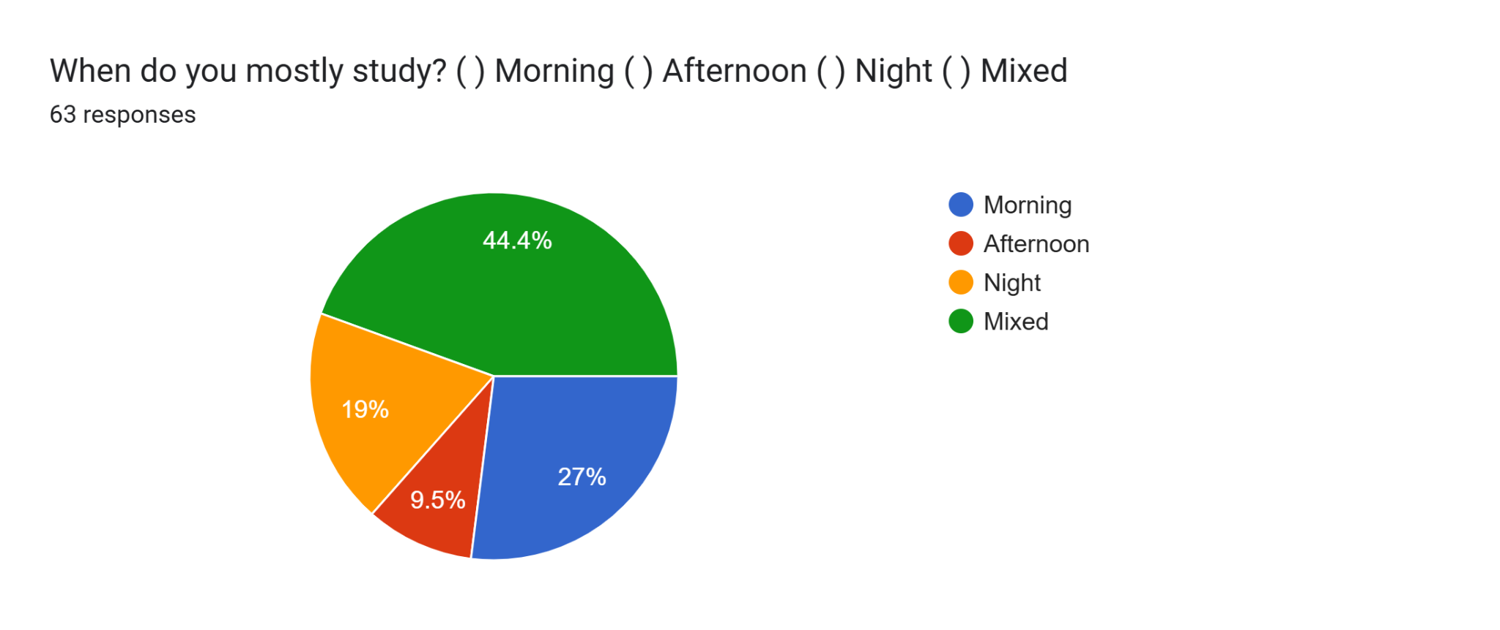

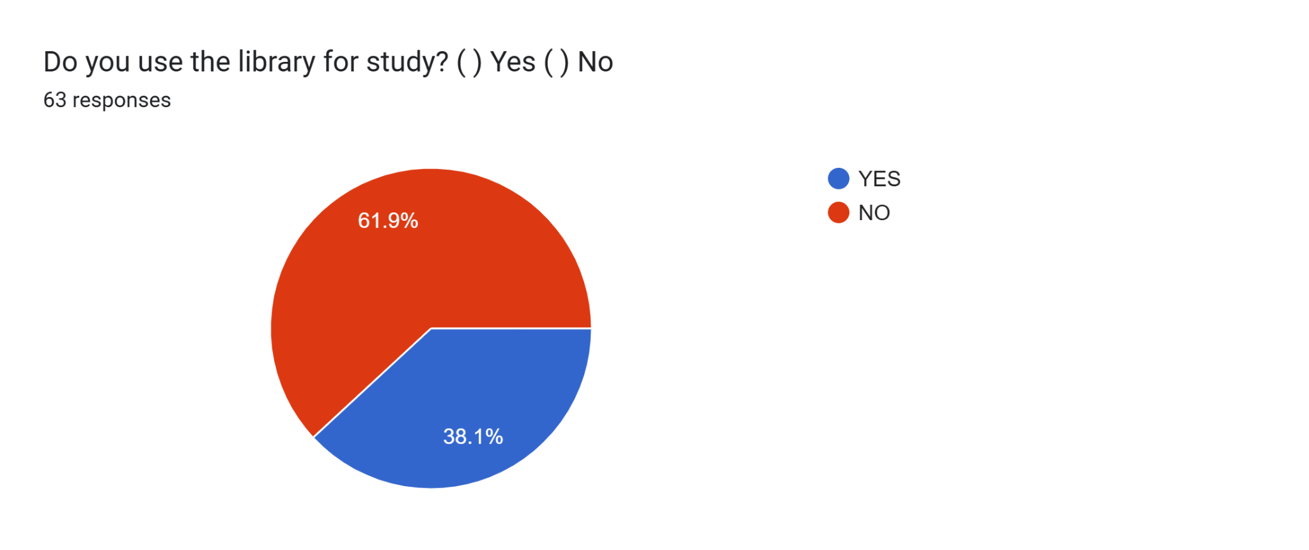

**IMAGES SHOWING OUR GROUP COLLECTING DATA USING THE QUESTIONNAIRE PAPER**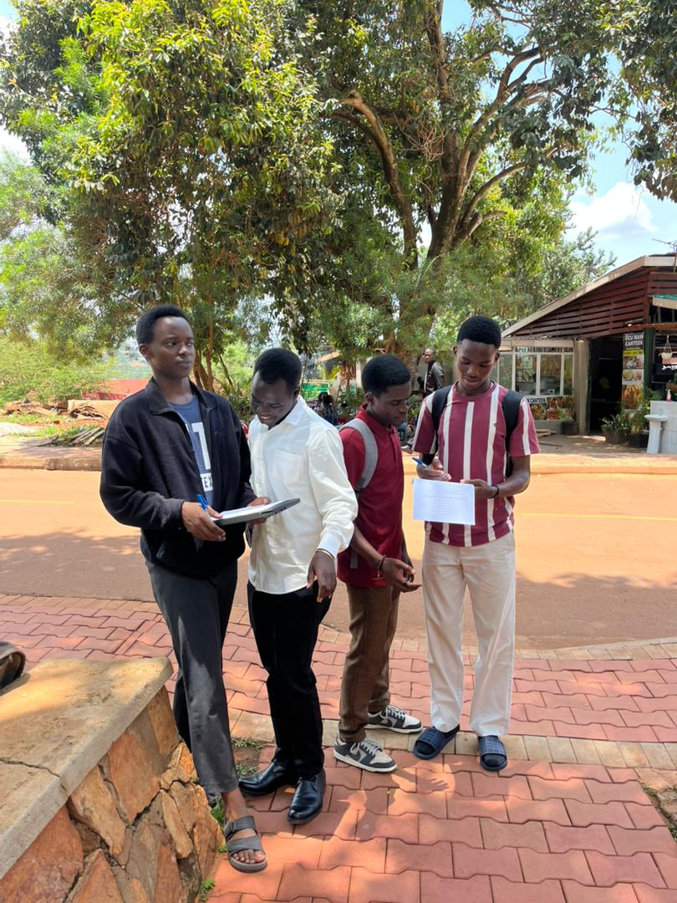

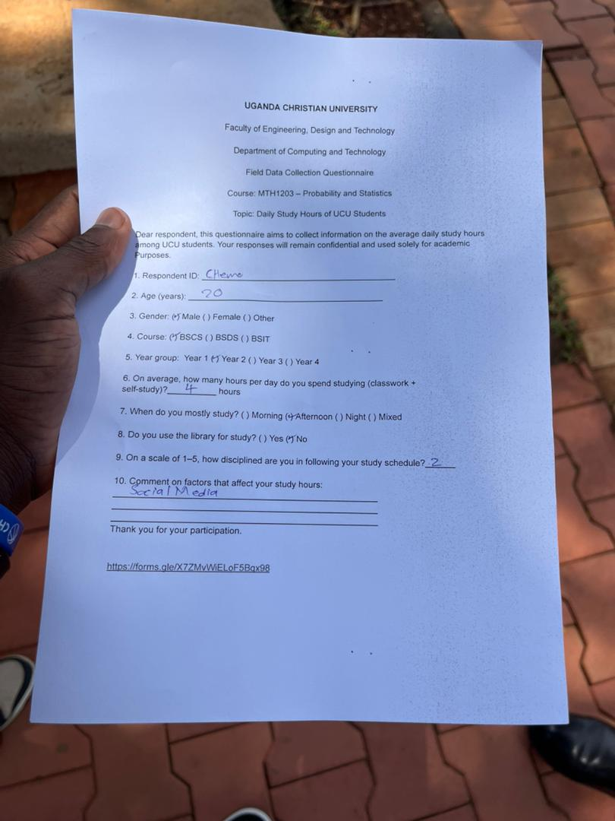

**CONCLUSION**

**The study concludes that the average UCU student studies about four hours per day. While most students maintain a consistent schedule, some show very low or very high study times. We recommended that students develop balanced study routines and utilize library resources effectively. Further research could compare study hours with academic performance to identify deeper trends.**

|  |  |  |
| --- | --- | --- |
| **GROUP MEMBERS** | **STUDENT_ID** | **CONTRIBUTION** |
| **MALISH EMMANUEL ABUI** | **M25B13/032** | **Questionnaire design.** |
| **MUGISHA ALVIN** |  | **chart generation** |
| **MUGISHA AMOS** | **M25B13/028** | **Report writing, formatting** |
| **KAYEMBA ISAAC FRANK** | **M25B13/O42** | **data verification** |
| **NYAKAANA CEDRIC CHARLES** | **M25B13/036** | **Quality assurance, editing** |
| **MUGISHA JOEL** | **M25B13/008** | **field data collection** |

